Apple M 1 CPU – reference:wikipedia

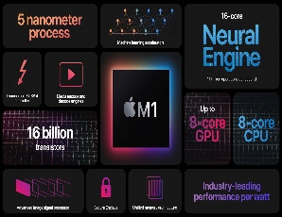

Apple M1-Changed entire industry

Apple M1 is a series of ARM-based systems-on-a-chip (SoCs) designed by Apple Inc. as a CPU and GPU for its Mac desktops and notebooks, and the iPad Pro and iPad Air tablets.

Apple's macOS and iPadOS operating systems both run on the M1. Initial support for the M1 SoC in the Linux kernel was released in version 5.13 on June 27, 2021.

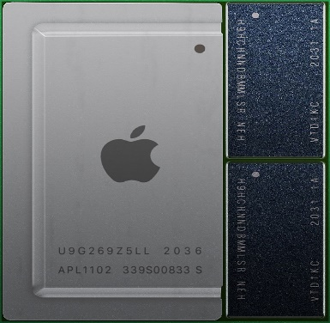

Progression

The M1 was introduced in November 2020. The M1 was followed by the professional-focused M1 Pro and M1 Max chips in 2021. The M1 Max is a higher-powered version of the M1 Pro, with more GPU cores and memory bandwidth and a larger die size. Apple introduced the M1 Ultra in 2022, combining two M1 Max chips in one package. These chips differ largely in size and the number of functional units: for example, while the original M1 has about 16 billion transistors, the M1 Ultra has 114 billion.

The M1 Ultra combines two M1 Max chips in one packagefor a total of 20 CPU cores and 96 MB system level cache (SLC).

GPU

The M1 integrates an Apple designed**eight-core** (seven in some base models) graphics processing unit (GPU). Each GPU core is split into 16 Execution Units, which each contain eight Arithmetic Logic Units (ALUs). In total, the M1 GPU contains up to 128 Execution units or 1024 ALUs, which Apple says can execute up to 24,576 threads simultaneously.

The M1 Pro integrates a 16-core (14 in some base models) graphics processing unit (GPU), while the M1 Max integrates a 32-core (24 in some base models) GPU. In total, the M1 Max GPU contains up to 512 execution units or 4096 ALUs.

The M1 Ultra features a 48- or 64-core GPU.

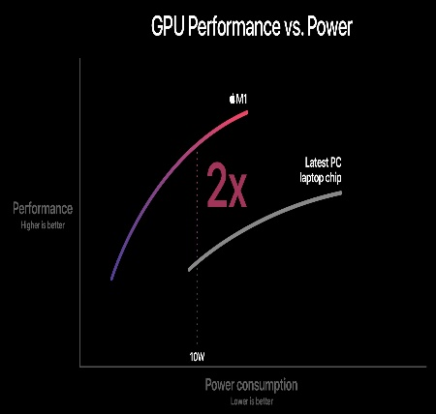

Some features

The M1 contains dedicated neural network hardware in a 16-core Neural Engine, capable of executing 11 trillion operations per second

The M1 recorded competitive performance and efficiency in popular benchmarks.

Problems

**USB power delivery bricking**

After its release, some users who charged M1 devices through USB-C hubs reported bricking their device.

The devices that are reported to cause this issue were third-party USB-C hubs and non-Thunderbolt docks (excluding Apple's own dongle). Apple handled this issue by replacing the logic board and by telling its customers not to charge through those hubs.macOS Big Sur 11.2.2 includes a fix to prevent 2019 or later MacBook Pro models and 2020 or later MacBook Air models from being damaged by certain third-party USB-C hubs and docks.

**Security vulnerabilities**

In June 2022 MIT researchers announced they had found a speculative execution vulnerability in M1 chips which they called "Pacman" after pointer authentication codes (PAC).Apple said they did not believe this posed a serious threat to users.

In May 2022 a flaw termed "Augury" was announced involving the Data-Memory Dependent Prefetcher (DMP) in M1 chips, discovered by researchers at Tel Aviv University, the University of Illinois at Urbana Champaign, and the University of Washington. It was not considered a substantial security risk at the time.

**Apple M2**

At the time of introduction in 2020, Apple said that the M1 had the world's fastest CPU core "in low power silicon" and the world's best CPU performance per watt. Its successor, Apple M2, was announced on June 6, 2022 at WWDC.

